**Homework 1**

**Name: Nafisa Tabassum Number: 202424600**

**Please note that if the network is not connected, the max grade is 7/10.**

**Router R0:** (2 points)

**show run | sec dhcp**

**show ip int bri | inc up**

**show ip route static**

**Multilayer Switch:** (3points)

**show ip int bri | inc up**

**show run | sec dhcp**

**show vtp status**

**show spanning-tree summary**

**show ip route static**

**Switch S1:** (1 point)

**show spanning-tree vlan 8**

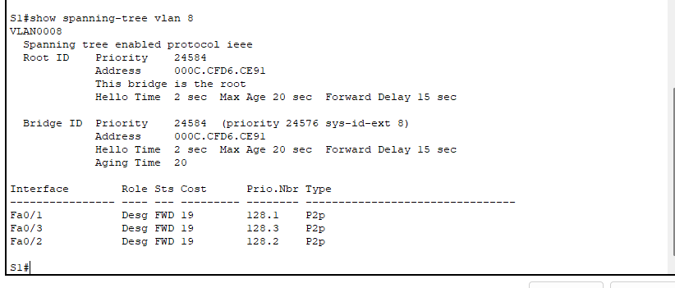

**show spanning-tree vlan 20**

**Switch S2:** (1 point)

**show spanning-tree vlan 8**

**show spanning-tree vlan 20**

**Switch S3 (take a snapshot for interfaces f0/1-4);** (0.5 points)

**show run | section interface**

**Switch S4 (take a snapshot for interfaces f0/1-4):** (0.5 points)

**show run | section interface**

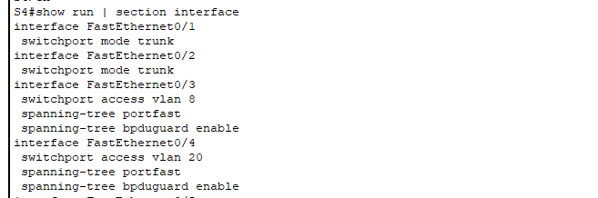

**Switch S5 (take a snapshot for interfaces f0/1-4):** (1 point)

**show run | section interface**

**Switch S6 (take a snapshot for interfaces f0/1-4) :** (1 point)

**show run | section interface**

